# CSC326 Final Project report

Lizhou Wang

998327733

Qiuyi Guan

998373175

# Part 1 Design highlights

In this part, we will discuss features we developed to enhance the search engine:

#### Front end:

Self designed LOGO (Hit Please)

We designed our website mobile/tablet friendly by implementing Bootstrap.

In frontend, we implemented an auto-correction system (mimic Google’s “Did you mean: xxx”)

#### Back end:

We used Mapreduce to calculate the PageRank (on Hadoop).

We implemented a multithread crawler.

We used mongoDB as our data warehouse.

#### Deployment:

We load balanced traffic to different cores, and got better max number of concurrent connection. Used async server (tornado) instead of default multithread in bottle.

Our code is available in lab4 submission file as well as Github: https://github.com/wlz1028/pl_works

## 1.1 Calculating PageRank using Mapreduce (Hadoop)

#### Motivation

Google introduced Mapreduce to calculate PageRank score on billions of webpages more than 100 times everyday. It’s impossible to fit all the data on a single machine, because of limited compute resources. Google simply distribute work to thousands of cheap computers. Google file system is a distributed file syste which responsible to store all the pages. In this lab, we used a popular Mapreduce Hadoop to implement a simple version of PageRank, and we actually ran the application on Hadoop.

On the other hand, Hadoop is extremely hot in data mining area. We hear it every day but never worked on Hadoop. It’s a great chance to get hands on experience.

#### Resources (references)

This article introduced how does Google calculate PageRank using Mapreduce

**[1]** http://www.cs.utah.edu/~jeffp/teaching/cs5955/L24-MR+PR.pdf

This article shows data structure and Mapreduce pseudo code (simple version)

**[2]** <https://code.google.com/p/joycrawler/downloads/detail?name=Readme-0.20.0.pdf&can=2&q>=

This article depicts how to write Hadoop application in python. The mapper and reducer take advantage of Hadoop streaming feature. All the input/output data are stdin/stdout, and handled by Hadoop streaming automatically. The article also gave a simple way to test mapper/reducer function on command line

**[3]**<http://www.glennklockwood.com/di/hadoop-streaming.php#wordcount:shuffle>

This article introduced how to install Hadoop on Ubuntu.

**[4]** <http://www.michael-noll.com/tutorials/running-hadoop-on-ubuntu-linux-single-node-cluster/>

#### Data structure

We will describe our own implementation of data structure based on article [1] and [2]. We will walk through a simple 4x4 example to illustrate our design.

For example we have the following graph:

**Matrix 1**

M = [ 0 1/3 0 1/2]

[ 1/2 0 0 0 ]

[ 0 1/3 0 0 ]

[ 1/2 1/3 1 1/2 ]

We can save it as a sparse matrix:

**Matrix 2**

1 2 4 # Page id= 1 has two links that point to page 2 and page 4

2 1 3 4

3 4

4 4 1

The first column represents each page id and followed by out link id (see above comment).

This data structure works well with our crawler, because when it crawls on a page, crawler simply output page id and followed by out links id (or saved to database directly).

#### Mapper

Each page has a PageRank score (denote as pr), and each page has k numbers of out links. So for each out links on a specific page, it will has a pr * 1/k probability to be clicked. For example, initially pr=1/4(where 4 is total page number) for matrix 2, so P(page2)=1/4*1/2, and P(page1)=1/4*1/2.

#### Reducer

Mapper out put multiple P with the same id. The reducer aggregates all P associate to the same page id, and then calculate

pr = beta*(p1+p2…)+(1-beta)*1/n

Where beta is the damping factor=0.85, and n is total number of page ids

#### Iteration

Each Mapreduce task yields a set of PageRank score. We can simply iterate the Mapreduce task until PageRank converge (article [2] mentioned that 15 iteration is good enough for most cases; for Google maybe 30+ iterations).

#### Implementation

Firstly, we need to improve the data structure for coding convenience purposes. We improve matrix 2 to the following:

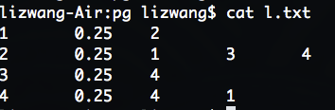

Where the second column is the PageRank score for the current page. As we mention before, initially we set PageRank = 1/n where n is the total number of page ids.

Then the mapper will output following data:

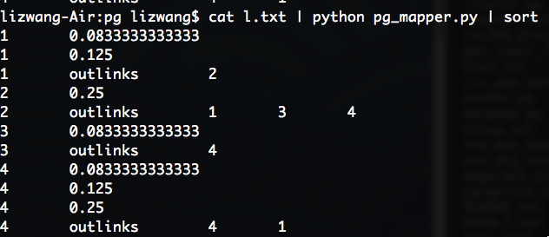

Where first column is page id, and second column is the probability (see mapper step above)

The 3rd row represent page id and out links relationship, so the reducer can output data, which can be fed to mapper in the next iteration.

The reducer consumes mappers output, and then out a set of PageRank score which can be fed to next Mapreduce iteration

The Mapreduce workflow:

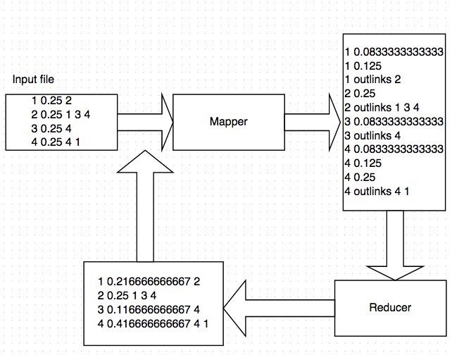

#### Mapper/Reducer in python

In this demo, we use Hadoop streaming feature to run python mapper and reducer. Basically, Hadoop streaming uses stdin/stdout to handles input/output data. So mapper/reducer consumes stdin and then yield stdout.

In later section, we will improve mapper/reducer by introducing generator. However, generator doesn’t work with linux pipe(‘|’) command which will be used to test mapper and reducer.

backEnd/pagerank_mapreduce/**pg_mapper.py**

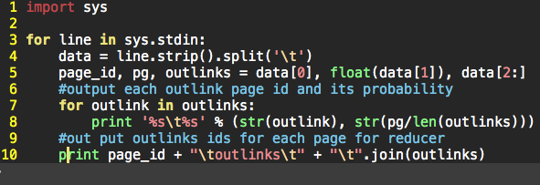

backEnd/pagerank_mapreduce/**pg_reducer.py**

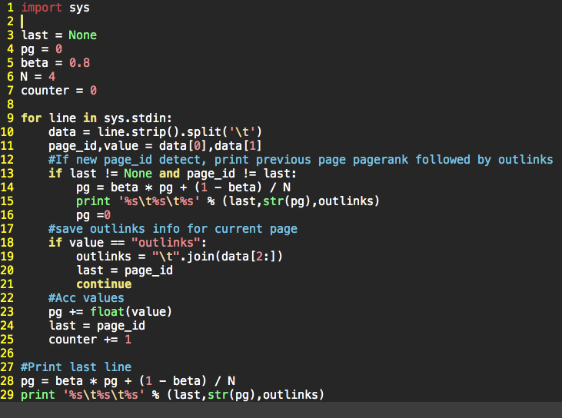

#### Testing on Linux command line:

Article [3] showed an elegant way to test mapper and reducer in classic word count example on command line. We test our mapper/reducer by using this method. We will use the 4x4 matrix we described above as the input.

**Input matrix**

1 0.25 2

2 0.25 1 3 4

3 0.25 4

4 0.25 4 1

First Mapreduce iteration:

$ cat pagerank.txt |python pg_mapper.py | **sort -k1n** | python pg_reducer.py

1 0.216666666667 2

2 0.25 1 3 4

3 0.116666666667 4

4 0.416666666667 4 1

**Note**: We sorted the mapper’s output by the first column(“sort -k1n”). In Hadoop, mapper will sort output by key (default key is the first column in Hadoop streaming) automatically

Next, we iterate Mapreduce task 30 times. We accomplish this in a simple bash script:

backEnd/pagerank_mapreduce/MR_iteration.sh

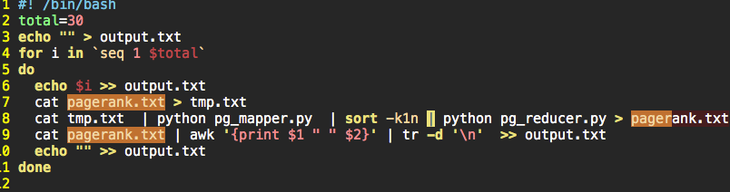

We can notice that after 20 iterations, PageRank converges (first 5 decimals)

cat output.txt

1

1 0.216666666667 2 0.25 3 0.116666666667 4 0.416666666667

2

1 0.283333333333 2 0.223333333334 3 0.116666666667 4 0.376666666667

3

1 0.260222222222 2 0.276666666666 3 0.109555555556 4 0.353555555556

4

1 0.2652 2 0.258177777778 3 0.123777777778 4 0.352844444445

5

1 0.259985185186 2 0.26216 3 0.118847407407 4 0.359007407408

6

1 0.263512296297 2 0.257988148149 3 0.119909333333 4 0.358590222222

7

1 0.262232928395 2 0.260809837038 3 0.118796839506 4 0.358160395062

8

1 0.262813447902 2 0.259786342716 3 0.119549289877 4 0.357850919506

9

1 0.26241672586 2 0.260250758322 3 0.119276358058 4 0.358056157762

10

1 0.262622665324 2 0.259933380688 3 0.119400202219 4 0.35804375177

11

1 0.262533068891 2 0.260098132259 3 0.119315568183 4 0.358053230667

12

1 0.262580794203 2 0.260026455113 3 0.119359501936 4 0.358033248749

13

1 0.262553687529 2 0.260064635362 3 0.11934038803 4 0.358041289078

14

1 0.262567085061 2 0.260042950023 3 0.11935056943 4 0.358039395485

15

1 0.262560544867 2 0.260053668049 3 0.119344786673 4 0.358041000411

16

1 0.262564044978 2 0.260048435894 3 0.119347644813 4 0.358039874316

17

1 0.262562199298 2 0.260051235982 3 0.119346249572 4 0.358040315149

18

1 0.262563122321 2 0.260049759438 3 0.119346996262 4 0.358040121979

19

**1 0.262562651308 2 0.260050497857 3 0.119346602517 4 0.358040248318**

**20**

**1 0.262562898756 2 0.260050121046 3 0.119346799429 4 0.358040180769**

#### Run Mapreduce on real Hadoop

Due to time limitation, we setup Hadoop on a single node to demonstrate out design. We followed article [4] to setup single a node on AWS. This node runs the following components including HDFS.

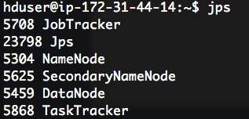

#### Copy to HDFS

First we copy our simple 4x4 matrix to HDFS:

hadoop dfs -copyFromLocal ./pagerank.txt pagerank/pagerank.txt

*In this demo, we use Hadoop streaming feature to run python mapper and reducer. Basically, Hadoop streaming uses stdin/stdout to handles input/output data. So mapper/reducer consumes stdin and then yield stdout.*

#### Run Mapreduce

> hadoop jar /usr/local/hadoop/contrib/streaming/**hadoop-streaming-1.0.3.jar**

-**mapper** "python/home/hduser/pl_works/backEnd/pagerank_mapreduce/**pg_mapper.py**"

-**reducer** "python/home/hduser/pl_works/backEnd/pagerank_mapreduce/**pg_reducer.py**"

-**input** "pagerank/pagerank.txt"

-**output** "pagerank/pagerank_1.result"

Copy result file from HDFS to local

hadoop dfs -copyToLocal pagerank/pagerank_1.result .

cat pagerank_1.result/part-00000 | sed 's/\t/ /g'

1 0.216666666667 2

2 0.25 1 3 4

3 0.116666666667 4

4 0.416666666667 4 1

Solution matches command line testing which demonstrated in previous section.

#### Run Mapreduce on Hadoop

Below screenshot displays the job details. Although the input file has only 4 lines(4x4 matrix), the job assigned two mappers, and only reducer. The runtime is 35 sec on Hadoop.

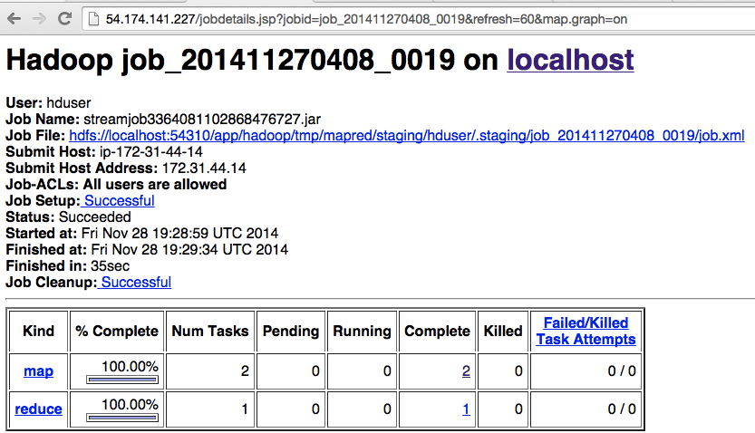

Next, we crawl on cbc.ca with depth=2, and generate a 16746 rows input file(which implies 16746 numbers of pages). The runtime is 37secs. Comparing with 4x4 matrix, the runtime increase 2 sec. We conclude that for Hadoop has huge overhead, so it’s not good for small data set.

**Input file:**

backEnd/pagerank_mapreduce/cbc_pr.txt

**Result screen shot**

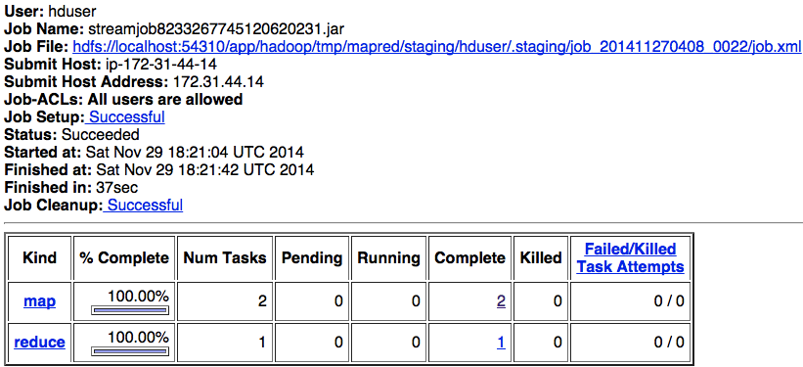

#### Improved Mapper/Reducer:

Inspired by Prof. Zhu’s lecture, instead of iterate stdin directly, we wrapped stdin into a generator. Generator saves memory and computation resource. Imagine input stdin is huge, without generator, the program saves all the stdin into memory and then iterate. However, with generator, each iterable element is generated on the fly. However, like we mentioned before, we won’t be able to test mapper/reducer by using pipe on command line.

Please see:

backEnd/pagerank_mapreduce/pg_mapper_generator.py

backEnd/pagerank_mapreduce/pg_reducer_generator.py

#### Conclusion:

We didn’t get any improvement by using Hadoop because 1) Hadoop should be used to analyze “big data”(terabytes of data) on many nodes, and our 2) our dataset is too small and Hadoop overhead is huge. However, theoretically, if we have billions of webpages, we can take advantage of HDFS that stores data across multiple nodes. Furthermore, HDFS is faults tolerant, so if one node is down, replicated data will be available on another node. Moreover, Mapreduce can distribute workload to multiple machines. Therefore, Hadoop is a better choice if data set is huge.

### 1.2 Multithread crawler

The single thread crawler is slower because the crawler is blocked by HTTP read which is slow. Our multithread crawler opens a new thread to handle HTTP read, and doesn’t block the crawler. Thread lock is used to keep common resources safe, such as url_queue. Please see comment in crawler_multi_Thread.py for details

We also tested our multithread crawler:

**\* Robustness testing:**

* Command:

- Run the following command 10 time

> python crawler_multi_Thread.py

# Default Setting

# URL = http://www.eecg.toronto.edu

# depth =2

* Result:

- 10 runs without crash

- CPU 68% usage

**\* Correctness testing:**

* Command:

python unit_test.py

* Setting:

compare number of word_id and url_id again single thread

* Result:

Some test runs failed due to different timeout in single thread and multithread. Otherwise, result is the same.

### 1.3 MongoDB

Instead of using 4 tables demonstrated in the handout, we created 2 collections (tables) in mongoDB. The advantage of mongoDB is that we don’t need to define schema. For example, in lab4, we need to store webpage title and descript into the database. In RDBMS(such as mySQL), we need to rewrite table schema, and update SQL statements. In mongoDB, we simply change each document(json) data structure.

### 1.4 Frontend mobile/tablet friendly

Mobile and tablet becomes extremely popular in recent year, so it becomes more important to design webpage which mobile/tablet friendly.

There are several options to achieve this goal.

#### Option 1:

On the sever side, the server can detect what kind of device is used by each user. The solution is that we can write multiple templates for each page that fit different resolutions. The sever will handle which template to send.

The big disadvantage of this solution is that the website becomes hard to manage because more templates have to be managed. It also burdens the server, and cause poor performance.

#### Option 2:

A popular way to solve this is by using Bootstrap. Bootstrap contains HTML and CSS-based design templates for typography, forms, buttons, navigation and other interface components, as well as optional JavaScript extensions. More importantly, Bootstrap adopted a mobile first design philosophy, emphasizing responsive design by default.

Bootstrap’s Grid system can adjust webpage base on different screen resolution. This article explains how to use bootstrap: <http://getbootstrap.com/examples/grid/>

Since Bootstrap is a HTML and CSS based templates, it doesn’t burden the server. Browsers generate right webpage for different screen resolution. It’s also easy for developer to maintain variable webpages.

#### Design decision

We pick option 2 to deign a mobile/tablet friendly website because it’s easier to maintain and performance better then option 1. Furthermore, there are tons of beautiful templates are available.

Sample mobile display out put:



### 1.4 Auto-correction

We take into account the possibility that a typo is encountered during the searching process. When user input a word that was not in our dictionary, the result page will have an option stating: “Did you mean: xxx”. In which ‘xxx’ will be a word’s correction based on our word_correction algorithm.

The word_correction algorithm was implemented based on Peter Norvig’s article, “How to Write a Spelling Corrector” which can be viewed on line. Since each word can have multiple corrections, a probability theory was explained in the article to calculate the probability of each corrected word, where we used as the ‘distance’ from the corrected word to the original word. The estimated distance was saved in a model called WORDS_COUNT.

Our algorithm first divides the string into multiple words and checks the correctness of each word separately. The algorithm computes all possibilities of the word by introducing 4 procedures: delete, transpose, replace and insert.

delete: go through each character and delete one at a time

transpose: switch two adjacent characters

replace: replace each character with ‘a’ to ‘z’

insert: insert one character at a time to different positions in the word

From above procedures, we save all possible words (words that is in our dictionary) into a set called candidate. Then, choose the element with the shortest distance, as estimated by the WORDS_COUNT model.

### 1.5 Deployment

#### Server choice:

Instead of default multithread server in bottle, we switched to Tornado (Facebook use it). Tornado only uses one thread to handle concurrent connection. It’s I/O non-block and uses async concept. For example, Tornado returns a state instead of waiting I/O request.

#### Load Balancing:

We opened multiple bottle application on different ports (e.g. 8081,8082,etc.). Each application is a single thread because we picked Tornado as our server. We used a popular Reverse Proxy server called Pound to load balance income traffic to different port randomly. See below diagram.

*see deploy.sh for pound configuration*

*see frontEnd/master.sh for launching two bottle apps on two ports*

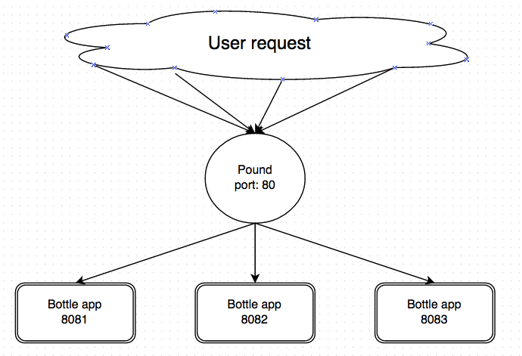

As result, we got 3000+ concurrent connections on query page(using mongoDB), and 4000+ concurrent connections on page without mongoDB. See rpts/connection_test.txt for test results.

# Part 2 Testing

#### Backend

To design backend, we wrote unit test cases before coding. In order to identify corner cases, we wrote unit tests on something we can control instead of run it on real cases directly.

Crawler testing:

Instead of crawling on real websites, we wrote a local testing HTML file to validate the crawler. This is because real websites are not predicable. When we run the crawler on the same website multiple time, we got inconsistent results due to different timeouts, and updates on the websites. Therefore, we never know what is the correct result.

To test multithreading crawler, we run it on our local testing HTML. Once this test passes, we run both single and multi thread crawler on real websites, and compares their result. However, due to different timeout and network condition, the results are not identical in some cases. Therefore, we set a tolerance value to the tester.

To test persistent storage, we crawl real website, and compare in memory data with persistent data.

#### Frontend

Instead of writing unit test cases, we record how do we use Google everyday, and then repeat it on our own website to test different functionalities.

# Part 3 Lesson learned

We learned the importance of label on our code. The entire lab was developed over a long period, sometimes we forgot what did we write in the previous functions or our to do list. By properly labeling the code, it saves us a lot of time remembering TODOs and the functionality of each step.

To keep track of our work, we used Github as our version control tool. Each of us works separately and commits all our work to Git. Since it was our first time using Git, we encountered many problems such as: we did not push our files correctly causing the partner may have worked on wrong version of the file.

# Part 4 Alternative

For the frontend, we should design our website mobile/tablet friendly at beginning. We had to rewrite some templates in the final project.

We spent a big amount of time on Hadoop, because we had zero experience on it. If we would have more time, we could setup Hadoop on multiple machines, and test our design on “big data”. Stanford University provides some real data (<http://snap.stanford.edu/data/>). We need to write another Mapreduce which coverts Stanford data to our own data structure.

# Part 5 Course materials

Lectures introduced many useful python technics. For example, we improved mapper/reducer jobs by using generator we learned in class.

# Part 6 Time out side lab session

Lab 1: 2hrs (one week)

Lab2: 5hrs (one week)

Lab3: 8hrs (two weeks)

Lab4 50+ hrs (one week) time distributed as following:

FrontEnd:

* (3hrs) result page Title and description(require update db)

* (5hrs) tablet, phone(bootstrap) friendly

* (2hrs) search key word auto correction

BackEnd:

(20hrs)PageRank map reduce

* Research 5 hrs

* Mapper/reducer 5 hrs

* CLI testing 2 hrs

* hadoop 8 hrs

deployment:

* (4 hrs)load balancing (pound) and multiple bottle apps on multiple cores

http://bottlepy.org/docs/dev/deployment.html

* (4 hrs) One-click deployment script:

Report:

5 hrs

Others(e.g. debugging): 5 hrs

# Part 7 Useful parts

We found deployment is useful especially on scalability part. We learned how to use Pound to load balancing on multiple cores, which the lab should spend more time on it.

# Part 8 Useless components

We didn’t find anything useless in the lab.

# Part 9 Feedbacks:

It would be better if we can have more time on last lab.

This project should have version control requirements. Our group used git (github) to manage our code.

# Part 10 Workload distributions and responsibilities

The workload of the lab was divided 50/50.

Qiuyi Guan is mainly in charged of front end, implementing some back end algorithms.

Lizhou Wand is mainly in charged of back end development and enhancement.